**MASTER Quick Guide for Accessing ECOSTRESS Data in NASA Earthdata Search**

*Updated February 2019*

Contents

How to search and download ECOSTRESS data in NASA Earthdata Search 2

Searching and downloading multiple ECOSTRESS data products from the same orbit 4

How to subset ECOSTRESS data according to day or night retrievals 8

# How to search and download ECOSTRESS data in NASA Earthdata Search

1. Go to <https://search.earthdata.nasa.gov/>
   1. Click the  button in the upper right hand corner to sign-in using your Earthdata Login account with restricted access
2. In the search engine, type the shortname of the data product, i.e. “ECO1BRAD” or simply search “ECOSTRESS”
   1. *Optional* Apply a search filter using spatial and/or temporal boundaries using the  tools in the search engine.
3. All matching collections will appear below
   1. Click anywhere in the rectangular box of a matching collection to view a list of available granules.

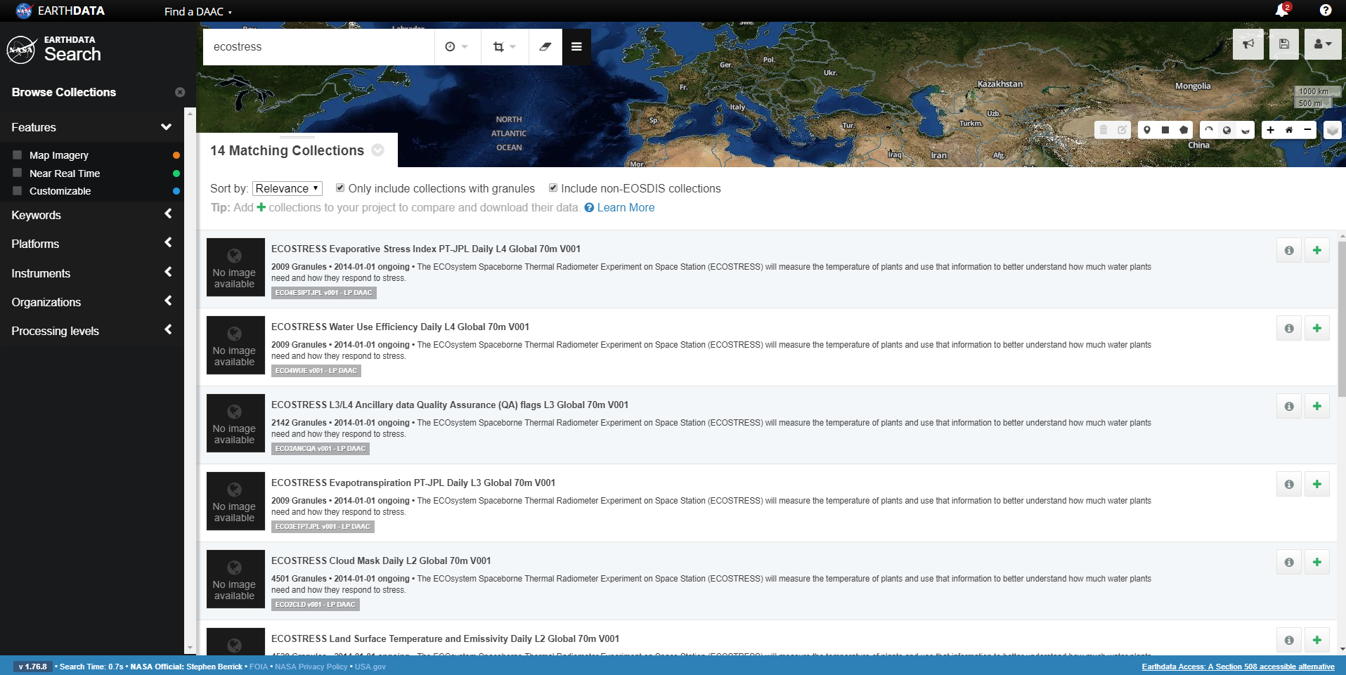

1. Download all granules associated with that collection using the tool located in the right-hand corner OR submit an order for an individual granule using the icon.

**Note**: Direct download is **not** available for ECOSTRESS L0-L4 products due to restricted access so you will be required to submit an order.

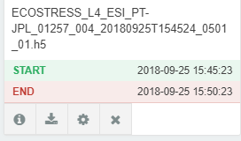

X

Using the icon above to submit an order, you will then be prompted to Select a Data Access Method, choose “Stage for Delivery.”

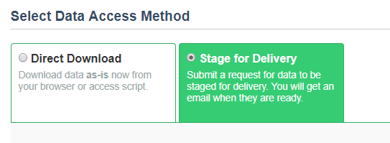

Continue and Submit order. You will receive order notifications via email.

# Searching and downloading multiple ECOSTRESS data products from the same orbit

1. Go to <https://search.earthdata.nasa.gov/>
   1. Click the  button in the upper right hand corner to sign-in using your Earthdata Login account with restricted access
2. In the search engine, type the shortname of the data product, i.e. “ECO1BRAD” or simply search “ECOSTRESS”
3. If you searched “ECOSTRESS,” all matching collections will appear below

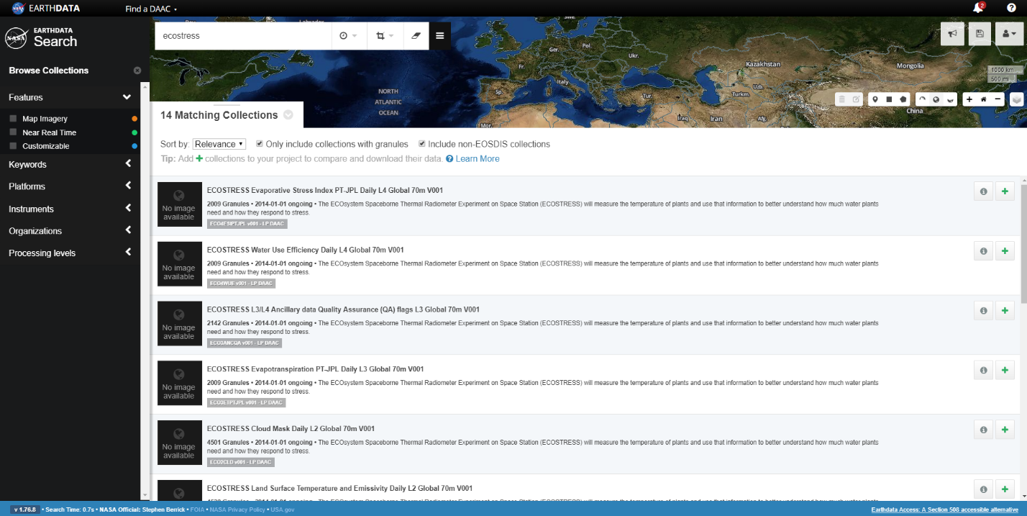

* 1. Select the icon of the data product that you would like to download to add them to your Project.

*Example: Select the* *for the ECO4ESIPTJPL and ECO1BGEO data products.*

* 1. In the top right corner of the webpage, a “My Project” icon will appear.

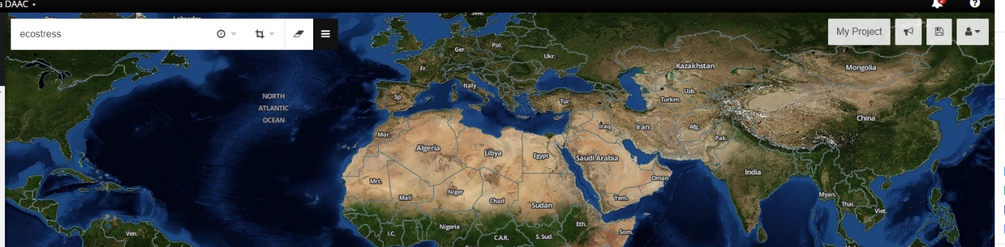

* 1. Select the “My Project” icon to view your project collections.

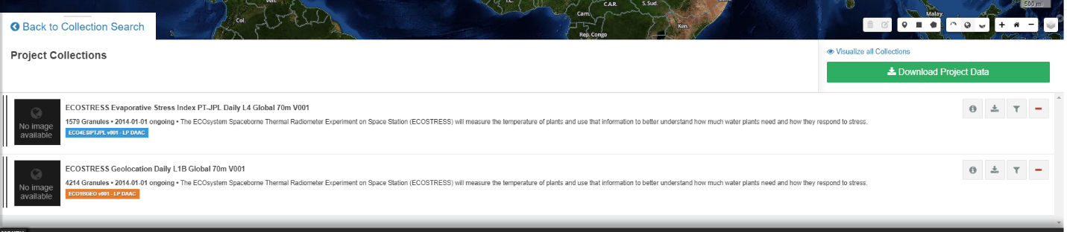

* 1. Adjust the granule filters using the icon to filter the granules for the ECO4ESIPTJPL product according to their orbit number.
     1. Note: the orbit number is provided in the filename:

ECOSTRESS_L4_ESI_PT-JPL_01316_003_20180929T105530_0501_01.h5

* 1. Using the granule filters menu, choose a min orbit number and max orbit number ex. 1316

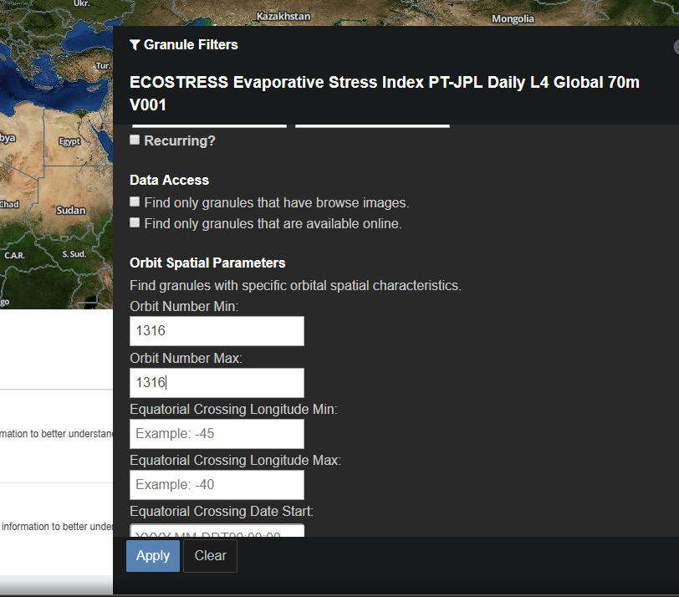

* 1. Repeat for all products in your project.

1. Review the results for each of the products:

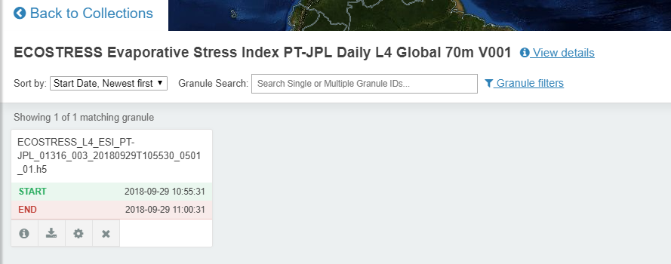

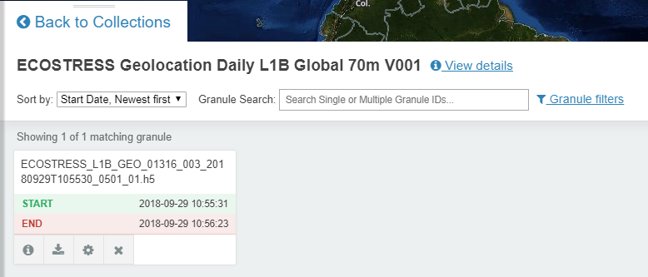

Here, we have a single granule for the ECO4ESIPTJPL and ECO1BGEO data products from the same orbit.

1. Go Back to Collections and select the Download Project Data icon to submit an order for the granules.

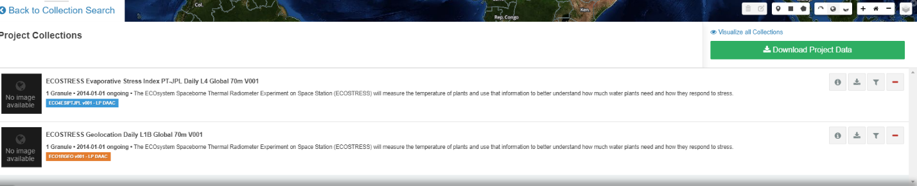

1. Select Stage for Delivery for each product:

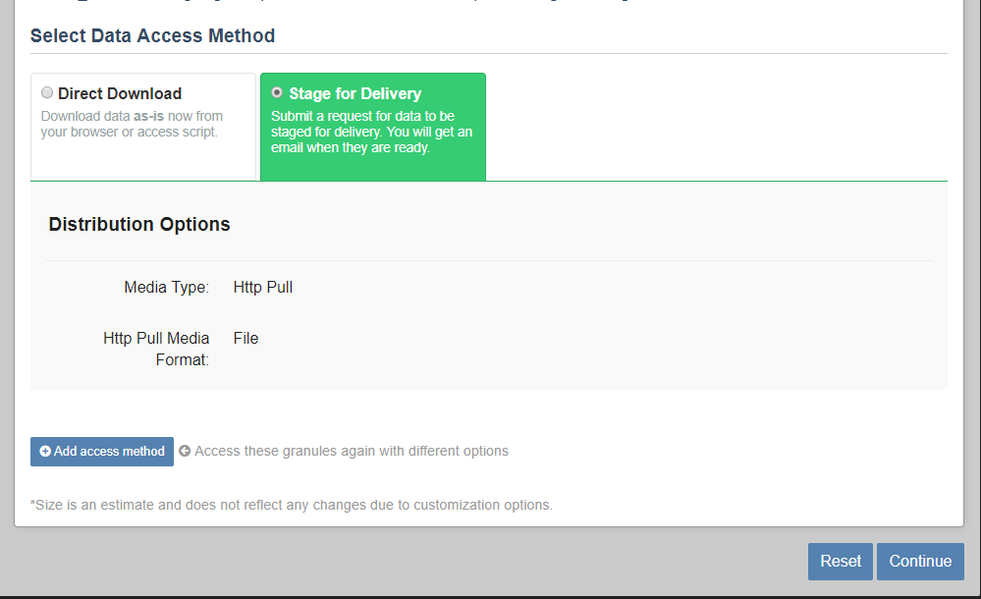

1. Continue and Submit order. You will receive order notifications via email.

# How to subset ECOSTRESS data according to day or night retrievals

1. Follow steps 1-3c in the section above on “Searching and downloading multiple ECOSTRESS data products from the same orbit in NASA Earthdata Search”
2. Adjust the granule filters using the icon to filter the granules for the ECO4ESIPTJPL product according to day/night acquisition
   1. In the Granule Filters menu, there is a Day/Night Flag option that allows you to find granules captured during the day, night, or anytime

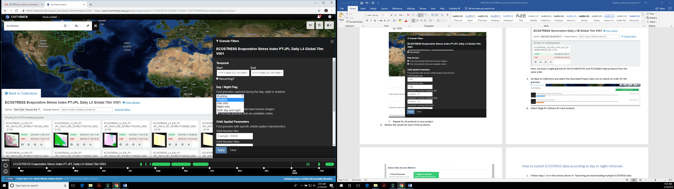

* 1. Repeat for all products in your project.

1. Go Back to Collections and select the Download Project Data icon to submit an order for the granules.



1. Select Stage for Delivery for each product:



1. Continue and Submit order. You will receive order notifications via email.